BACKEND DEVELOPMENT PROJECT DOCUMENTATION

CONTACT MANAGER

- Team id:69a65f13d4127454df35160c
- Team Leader:M. Santhiya
- Team Member1:Rithika S
- Team Member2:Roshini R
- Team Member3:Saralnila M
- Team Member4:Sri dhana janani

PROJECT OVERVIEW
The ConnectHub is a backend web application designed to solve the common problem of scattered contact information across multiple platforms. It provides users with a centralized, organized system to store, search, and categorize their professional and personal contacts.
Key Objectives:
• Provide secure user authentication and data isolation
• Enable efficient contact management through CRUD operations
• Implement flexible categorization using tags
• Offer fast search and filtering capabilities
• Deliver a responsive, cross-device user experience
Target Users:
• Freelancers and consultants managing client relationships
• Small business owners tracking vendor and customer contacts
• Students and young professionals building their network
• Event organizers managing attendee and volunteer information
• Anyone seeking a simple, privacy-focused contact management solution

PROJECT INSTRUCTION
1️⃣ Install Node.js (If Not Installed)
Download and install Node.js from: https://nodejs.org/
After installation, verify:
node -v
npm -v

2️⃣ Create a Backend Project Folder
• Choose or create a directory where you want your backend.
• Open your terminal or command prompt.
• Navigate to the selected directory:
cd your-project-folder
• Create a new backend folder:
mkdir server
cd server
3️⃣ Initialize Node Project
Run: npm init -y
This will create a package.json file.
4️⃣ Install Required Dependencies
Install Express:
npm install express
npm install mongoose
For development (auto-restart server):
npm install nodemon --save-dev

5️⃣ Create Basic Server File
Inside the server folder:
• Create a file called: server.js
Add this code

6️⃣ Enable ES Modules (Important)
Open package.json and add: "type": "module"
Example:
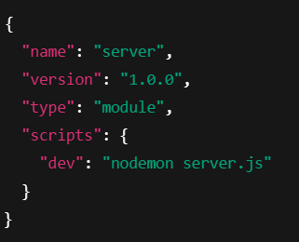
7️⃣ Start the Backend Server
Run: npm run dev
OR if not using nodemon: node server.js

8️⃣ Open in Browser
Open: http://localhost:5000
You should see: Backend is running

PRE-REQUISITES
Software Requirements
Software
Purpose
Node.js
JavaScript runtime for backend
MongoDB
NoSQL database for data storage
npm
Package manager
Git
Version control system
Code Editor
VS Code, WebStorm, or similar

Knowledge Requirements
• JavaScript ES6+ syntax and concepts
• Node.js and Express.js for RESTful API development
• MongoDB and Mongoose ODM
• JWT authentication and bcrypt password hashing
• Git version control workflow
PROJECT THUMBNAIL

PROJECT ARCHITECTURE
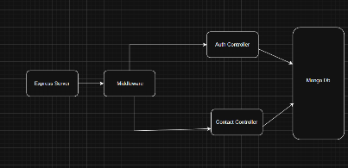
High-level architecture diagram illustrating the three-tier backend structure.
Node.js + Express Backend
• RESTful API architecture
• JWT authentication middleware
• MVC pattern (Models, Controllers, Routes)
• Input validation and error handling

MongoDB Database
• Document-based NoSQL storage
• Mongoose ODM for schema modeling
• Two collections: Users and Contacts
• Indexed fields for optimized queries

TECHNICAL ARCHITECTURE
Backend Architecture (Node.js + Express)
• Controllers: Business logic for authentication and CRUD operations
• Models: Mongoose schemas defining data structure
• Routes: API endpoint definitions with HTTP methods
• Middleware: JWT verification, error handling, validation
• Configuration: Database connection and environment variables
Database Architecture (MongoDB)
• Users Collection: _id, name, email, password (hashed), timestamps
• Contacts Collection: _id, userId (FK), name, email, phone, notes, tags[], timestamps
• Relationships: Many-to-One (Contacts → User)
• Indexes: email (unique), userId, name, tags (for search)
ER Diagram
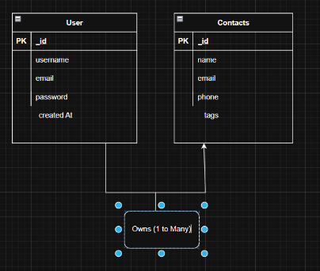
Features
Core Features

#
Feature
Description
1
User Authentication
JWT-based registration, login, and session management with bcrypt password hashing
2
Contact CRUD
Create, read, update, and delete contacts with full validation and error handling
3
Tag Categorization
Organize contacts with multiple tags (Work, Family, Friends, etc.) and filter by category
4
Real-time Search
Debounced search across name, email, and tags with instant results

Roles and Responsibility

User -

Registration - Register on the application using the name, email , password
Login - Login on the application using the email and registered password
Search - Search for a contact using name , email or tags
Add Contact - Add new contact - name , email , phone , notes , tags
Edit Contact - Edit the existing contact
Delete Contact - Delete any contact
User Flow
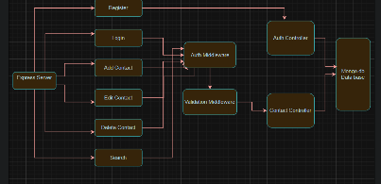
Project Setup and Configuration
Folder Structure
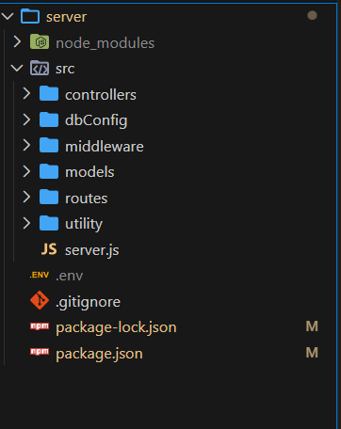
Project Setup

1. Install required tools and software:
Node.js.
MongoDB.
2. Create project folders and files:
Server folders.
3. Install Packages:
Backend npm Packages
Express.
Mongoose.
Cors.

Backend Development
Setup express server
Create index.js file in the server (backend folder).
Create a .env file and define port number to access it globally.
Configure the server by adding cors, body-parser.
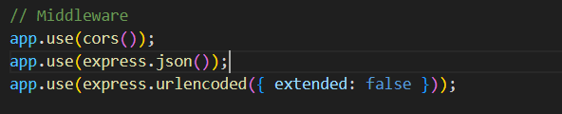

User Authentication:
• Create routes and middleware for user registration, login, and
• Set up authentication middleware to protect routes that require user authentication.
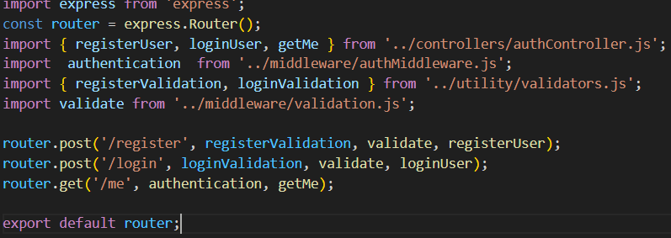

Define API Routes:
• Create separate route files for different API functionalities such as user authentication and crud operation for contacts
• Implement route handlers using Express.js to handle requests and interact with the database.
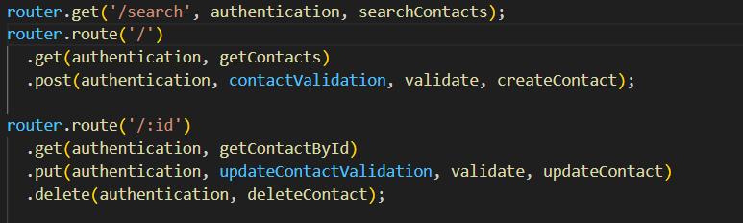
Implement Data Models:
• Define Mongoose schemas for the different data entities like user and contact
• Create corresponding Mongoose models to interact with the MongoDB database.
• Implement CRUD operations (Create, Read, Update, Delete) for each model to perform database operations.
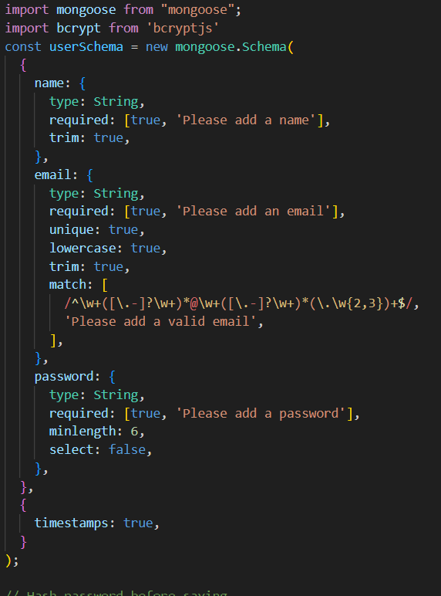
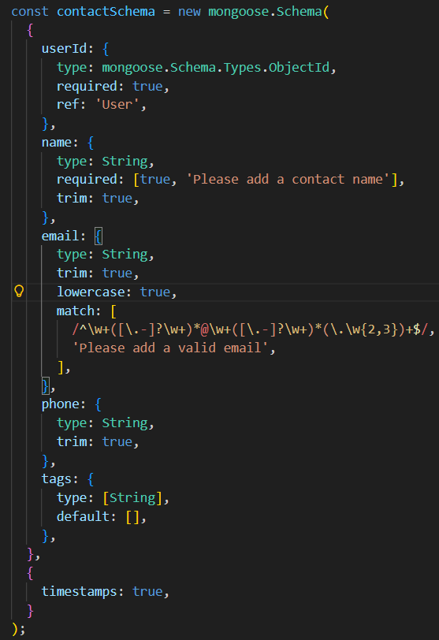
Error Handling:
• Implement error handling middleware to catch and handle any errors that occur during the API requests.
• Return appropriate error responses with relevant error messages and HTTP status codes.
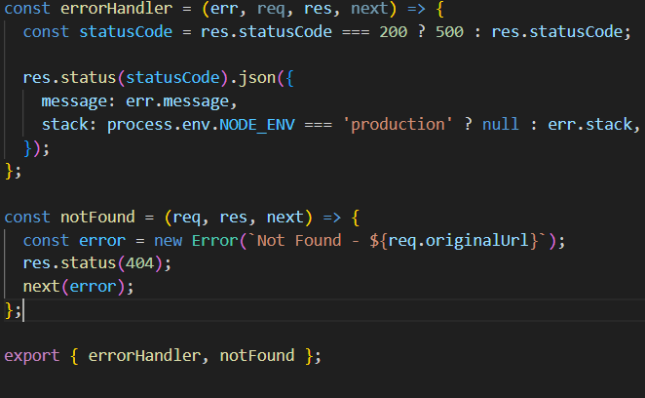

Database Configuration and Setup
1. Configure MongoDB:
Install Mongoose.
Create database connection.
Create Schemas & Models.

2. Connect database to backend:
Now, make sure the database is connected before performing any of the actions through the backend. The connection code looks similar to the one provided below.
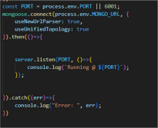
3. Configure Schema:
Firstly, configure the Schemas for MongoDB database, to store the data in such pattern. Use the data from the ER diagrams to create the schemas.
The schemas are looks like for the Application.
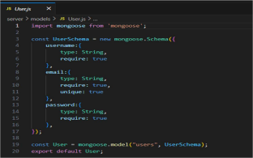
Project Execution

Execution Steps
Open the project folder in the terminal
Make sure you have a start script in the package.js file
Use the command npm start to start the server
You will the Running on PORT message on the successfully starting the server
You will also see the database connected message if the database is connected successfully
Use the Thunder client or Postman for using the created api’s

Output Screenshots
Register Api
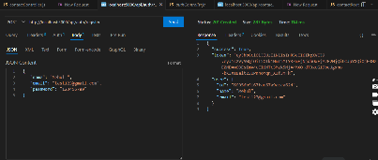
Login Api
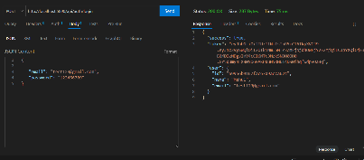
Create New Contact
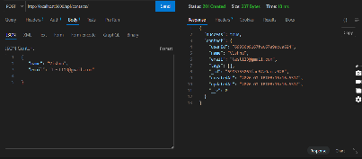
Update Contact
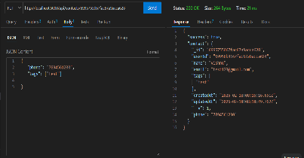
Delete Contact
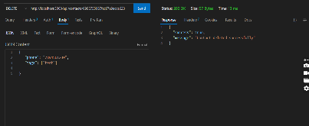
Search Contact
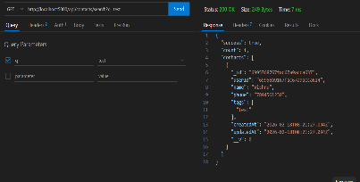
Get The Current User

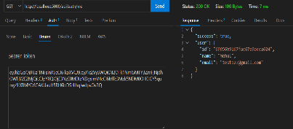

Project Demo
Contact Manager.webm
Contact Manager
Ideation Phase
Brainstorm & Idea Prioritization

- Date: 17/02/2026
- Team ID:
- Project Name :Contact Manager

Brainstorm & Idea Prioritization
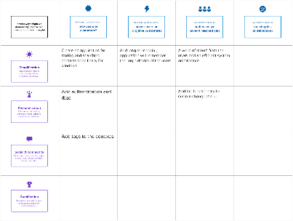

Ste 2 : Idea Prioritization
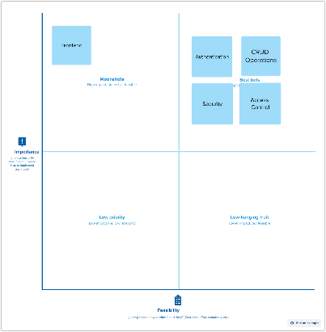

Contact Manager
Ideation Phase
Empathize & Discover

Empathy Map Canvas:
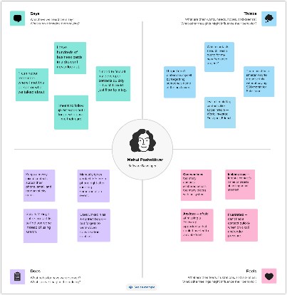

Contact Manager
Ideation Phase
Define the Problem Statements
Problem Statement

People struggle to effectively manage and maintain their growing professional and personal networks because existing solutions are either too complex, too expensive, or lack the simplicity needed for quick contact organization and retrieval.
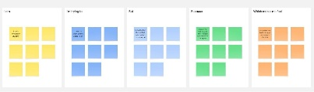
Problem Statement (PS)
I am (Customer)
I’m trying to
But
Because
Which makes me feel
PS-1
A university student
Store and retrieve contacts on the laptop
Most platforms are only available for mobile phones
I need quick access to my contacts while i am working
Frustrated
PS-2
A developer
Get the required contacts on laptop while working
The available applications are for mobile phone
I need a simple, visually appealing interface to store and get my contacts
Waste of time to continuously use mobile while working

Project Design Phase-II
Data Flow Diagram & User Stories

Data Flow Diagrams
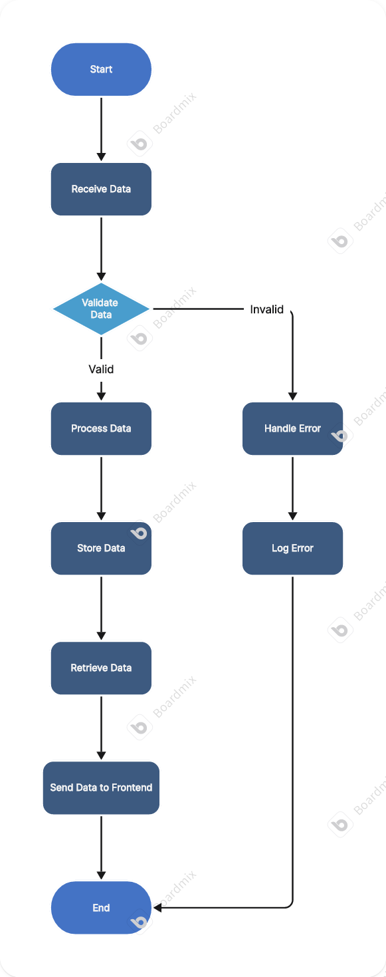

User Stories

User Type
User Story Number
User Story / Task
Acceptance criteria
Priority
Release
Student
USN 1
As a user i can add and update the contacts ant any time
Fast addition and update
High
Sprint 1
Developer
USN 2
As a user i can search for the contacts fast
Fast search results
High
Sprint 1
Manager
USN 3
As a user i can view the contacts of my team and update them as required
Fast update and fetch
High
Sprint 2

Project Design Phase-II
Solution Requirements (Functional & Non-functional)

Functional Requirements:
Following are the functional requirements of the proposed solution.

FR No.
Functional Requirement (Epic)
Sub Requirement (Story / Sub-Task)
1
User Authentication and Authorization
• User registration with name, email, and password
• User login with email and password
• JWT token generation and management
• Password encryption using bcrypt
• Session management and auto-logout on token expiration
• Protected routes requiring authentication
• User logout functionality
2
Contact Management (CRUD Operations)
• Create new contact with name, email, phone, notes, and tags
• View all contacts for logged-in user
• View individual contact details
• Update existing contact information
• Delete contact with confirmation prompt
• Validate contact data (email format, required fields)
• Display contact count and metadata
3
Search and Discovery
• Real-time search across contact names
• Search by email addresses
• Search by tags
• Case-insensitive search functionality
• Display search results count

4
Data Validation and Error Handling
• Server-side validation for all API endpoints
• Email format validation
• Required field validation
• Display validation errors to user
• API error handling and user-friendly messages
• Prevent duplicate email registration
5
Contact Information Management
• Store contact name (required)
• Store contact email (optional, validated)
• Store contact phone number (optional)
• Store contact notes/description (optional, max 1000 chars)
• Store contact tags (optional, max 10 tags)
• Timestamp for contact creation
• Timestamp for last update
6
User Profile and Account
• Get current user information endpoint
• User-specific data isolation
• Each user accesses only their own contacts
• User ID association with all contacts

7
Data Persistence and Storage
• Store user data in MongoDB database
• Store contacts in MongoDB database
• Maintain referential integrity (userId foreign key)
• Automatic timestamp management
• Database indexing for performance
• Secure password storage (hashed)
• LocalStorage for JWT token on client

Non-functional Requirements:
Following are the non-functional requirements of the proposed solution.

FR No.
Non-Functional Requirement
Description
1
Security
All API requests must be secured using JWT authentication. The app should prevent unauthorized access to user data. Passwords must be hashed using bcrypt with salt rounds of 10 or higher. SQL/NoSQL injection attacks should be prevented through input validation and parameterized queries. CORS properly configured to allow only authorized origins. Sensitive data (passwords) never exposed in API responses. HTTPS enforced in production environments.
2
Reliability
The system should handle errors gracefully without crashing. Database connections should be resilient with automatic reconnection. Failed API requests should be handled with appropriate error messages.
3
Performance
API response times should average under 200ms. Database queries optimized with appropriate indexing. Client-side rendering should be smooth (60fps animations). Bundle size kept under 500KB for fast loading.
4
Scalability
The app should handle increasing numbers of users and contacts efficiently without performance degradation. The architecture should support future feature expansion. Should support at least 10,000 concurrent users. Individual users should be able to store up to 10,000 contacts without performance issues. Database should scale horizontally
5
Maintainability
The codebase should be well-organized, documented, and easy to maintain. Code should follow consistent style guidelines and best practices. Functions should be modular and single-purpose. Comments should explain complex logic. API endpoints should be clearly documented. Database schema should be well-defined. Version control with meaningful commit messages. Separate development, staging, and production environments.
6
Compatibility
The application should work across different browsers and devices. Support for Chrome (latest 2 versions), Firefox (latest 2 versions), Safari (latest 2 versions), Edge (latest 2 versions). Mobile support for iOS 12+ and Android 8+. Responsive design working on screen sizes from 320px to 2560px. No dependency on specific operating systems. API compatible with different client types (web, mobile, future integrations).
7
Data Privacy and Compliance
User data should be handled in accordance with privacy regulations. Each user can only access their own data. No sharing of user data with third parties. Data deletion on account removal (future feature). Clear privacy policy available. Compliance with GDPR principles (data minimization, purpose limitation). User consent for data processing.

Project Design Phase-II
Technology Stack (Architecture & Stack)

Technical Architecture:
The Deliverable shall include the architectural diagram as below and the information as per the table1 & table 2
Table-1 : Components & Technologies:
S.No
Component
Description
Technology
1
Application Logic-1
Data storage and updation in the database
Node, Express , Mongodb
2
Application Logic-1
Data retrieval
Node , Express , MongoDb,

Table-2: Application Characteristics:

S.No
Characteristics
Description
Technology
1
Open Source Frameworks
Backend Frameworks
Node , Express ,
2
Scalability
Securing API calls and access controls
JWT authentication ,

Project Planning Phase
Project Planning Template (Product Backlog, Sprint Planning, Stories, Story points
Product Backlog, Sprint Schedule, and Estimation (4 Marks)

Sprint
Functional Requirement (Epic)
User Story Number
User Story / Task
Story Points
Priority
Team Members
Sprint 1
Project Setup
USN 1
Set up Node.js project structure with necessary dependencies
10
High
Mehul
Sprint 1
User and Contact Schema
USN 2
Create the schema model for user and contact
10
High
Mehul
Sprint 2
Controllers
USN 3
Create the auth and contact controllers
10
High
Mehul
Sprint 2
Middleware
USN 4
Create the jwt authentication and data validation middleware
10
High
Mehul
Sprint 3
Routes
USN 5
Create the auth and contact CRUD routes
10
High
Mehul
Sprint 3
Server file
USN 6
Create an server.js file to start the server and define the api routes
10
High
Mehul
Sprint 4
Debugging and Testing
USN 7
Debug the whole project and test the api’s
10
High
Mehul

Project Tracker, Velocity & Burndown Chart: (4 Marks)

Sprint
Total Story Points
Duration
Sprint Start Date
Sprint End Date (Planned)
Story Points Completed (as on Planned End Date)
Sprint Release Date (Actual)
Sprint 1
20
1 Day
13/05/2026
14/02/2026
20
14/02/2026
Sprint 2
20
1 Day
14/02/2026
15/02/2026
20
15/02/2026
Sprint 3
20
1 Day
15/02/2026
16/02/2026
20
16/02/2026
Sprint 4
20
1 Day
16/02/2026
16/02/2026
20
16/02/2026

Project Design Phase
Solution Architecture

Solution Architecture:
The solution architecture for the Contact Manager application a scalable, efficient, and user-friendly platform for storing , updating and searching the the saved contacts or adding new ones.

Goals of the Solution Architecture:
Identify the Best Tech Solution:
Utilize modern backend frameworks like Node and Express to provide fast responses and efficient development
Define Structure & Characteristics:
Ensure a modular, scalable, and maintainable software architecture that supports future feature enhancements like bulk deletion , bulk addition of contacts
Outline Features & Development Phases:
Clearly define project milestones, including schema creation , data base queries and api development
Establish Specifications for Development & Delivery:
Provide well-defined guidelines for system architecture, API development , data flow, and real-time data handling.
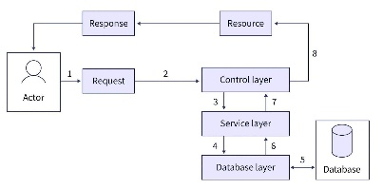

Project Design Phase
Proposed Solution

Proposed Solution Template:
Project team shall fill the following information in the proposed solution template.
S.No.
Parameter
Description

Problem Statement (Problem to be solved)
Many users struggle to find an efficient tool to save important contacts and organize them and find the specific contact while working on the laptop or desktop computer .

Idea / Solution description
A node and express based application that is user authenticated and performs CRUD operations for the contacts efficiently and and fast . It can be used directly from the WINDOWS PC

Novelty / Uniqueness
Free and structured way of adding new contact or editing existing contacts and performing search operation based on the name , email or the tags

Social Impact / Customer Satisfaction
Provides everyone who are busy with work and no time to use mobile phone a way to see there contacts without being disturbed

Project Design Phase
Problem – Solution Fit Template

Problem – Solution Fit Overview:
The Problem-Solution Fit ensures that the identified problem aligns with the needs of users and that the proposed solution effectively addresses it. This concept helps developers, marketers, and business strategists validate the necessity and effectiveness of their solution before further development.
Purpose:
Address the lack of efficient application for storing and searching the contacts on the laptop or desktop
Provide a way to see and update the contacts on the go while working on the laptop
Improve the accessibility to the saved contacts and a search functionality

Problem Statement:
People struggle to effectively manage and maintain their growing professional and personal networks because existing solutions are either too complex, too expensive, or lack the simplicity needed for quick contact organization and retrieval.

Solution :
A Node . js based backend to perform CRUD operations on the contacts
Categorization, filtering, and search functionalities improve accessibility and user engagement.
Integration with the mongo_db for storing the data of the users and contacts and performing the CRUD operations
JWT based user authentication
User Acceptance Testing (UAT) Template

Project Overview
📌 Project Name: Contact Manager
📌 Project Description: A node js and express based backend to perform user authentication using jwt and perform CRUD operations on the contacts
📌 Project Version: v1.0
📌 Testing Period: Feb 15 2026- Feb 16 2026

Testing Scope
Features and Functionalities to be Tested
✅User Registration
✅User Login
✅Adding new Contact
✅Updating the existing contact
✅Searching for the particular contact
✅Receiving the current user details
✅Error handling
✅Authentication using JWT

User Stories or Requirements to be Tested
📌Searching and Viewing all the contacts
📌Adding new contacts
📌Updating existing contacts
📌Handling error

Test Cases

Test Case ID
Test Scenario
Test Steps
Expected Result
Actual Result
Pass/Fail
TCI 1
User Registration
Launch Thunder client
Use the registration api in the url box
Change the method to post
In body put the required fields and the values
A json response with the user details
A json response with the user details
pass
TCI 2
User Login
Use login api in the url
Change the method to post
In body put the email and password fields
A json response with the user details and a jwt token
A json response with the user details and a jwt token
pass
TCI 3
Adding new contact
Use the create contact api
Change the method to post
In the body put the contact details
A json response with success true , total contact count , and the contact object
A json response with success true , total contact count , and the contact object
pass
TCI 4
Updating the contact
Use the updating contact api
Change the method to post
In the body put the fields to be updated
A json response with success true , total contact count , and the updated contact object
A json response with success true , total contact count , and the updated contact object
pass
TCI 5
Deleting the contact
Use the delete contact api
Change the method to delete
In the query put the contact id
A json with success true and message saying - contact deleted successfully
A json with success true and message saying - contact deleted successfully
pass

